## **RH-ISAC Summit: Sponsor Marketing Kit**

**SOCIAL MEDIA PROMOTION**

To help promote the RH-ISAC Cyber Intelligence Summit, please use the sample text below to highlight the event on your company’s LinkedIn and/or Twitter profiles.

**{Company Name} is collaborating with** [@Retail & Hospitality ISAC](https://be.linkedin.com/company/retail-hospitality-isac) **as a sponsor for the upcoming Cyber Intelligence Summit on April 9 – 11 in Denver! Join us and the rest of the retail and hospitality cybersecurity community for a best-in-class event! Register today at** [**https://summit.rhisac.org**](https://summit.rhisac.org)

Tag RH-ISAC in your post:

* Twitter: [@RH_ISAC](https://twitter.com/RH_ISAC?ref_src=twsrc%5Egoogle%7Ctwcamp%5Eserp%7Ctwgr%5Eauthor)
* LinkedIn: [@Retail & Hospitality ISAC](https://be.linkedin.com/company/retail-hospitality-isac)

Add hashtags:

* #infosec
* #cybersecurity
* #RHISACSummit
* #ProtectAsOne
* Any others related to your company

Feel free to edit the suggested text above to fit your needs, but don’t forget to include the following:

* Session topic
* Date and time
* Register at <https://summit.rhisac.org>

Graphic:

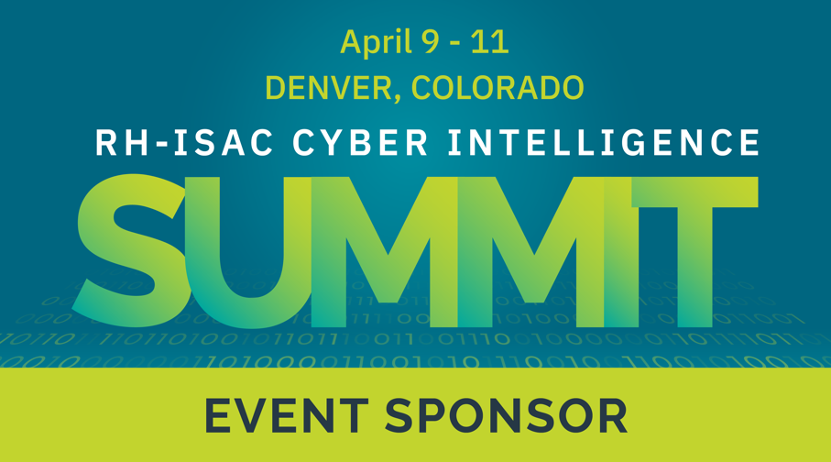

# sample press release

To help promote the RH-ISAC Cyber Intelligence Summit, please feel free to use the below template as a starting point for a writing press release about the event.

### [Company Name] Partners with the Retail and Hospitality at the Cyber Intelligence Summit

**[City, State (Month XX, Year)]** – [COMPANY NAME] today announced that it will partner with [The Retail & Hospitality Information Sharing and Analysis Center](https://rhisac.org/) (RH-ISAC) as a sponsor for RH-ISAC’s [RH-ISAC’s Cyber Intelligence Summit](https://summit.rhisac.org/).

The Summit is a three-day event that brings together information security professionals who work in retail, hospitality, or other consumer-facing businesses for networking and education with peers from around the world. This year’s event takes place April 9-11 in Denver, Colorado.

{Company Name’s} sponsorship will provide attendees with the opportunity to learn more about {Company Name’s} [product or service related to retail and hospitality cybersecurity needs].

The Summit is open to any cybersecurity practitioner that works in the consumer-facing sector. Registration is required. Visit <https://summit.rhisac.org> for more information.

###

***About Company****[INSERT COMPANY BOILERPLATE]*

***About RH-ISAC*** *The Retail & Hospitality Information Sharing and Analysis Center (RH-ISAC) is the trusted community for sharing sector-specific cybersecurity information and intelligence. The RH-ISAC connects information security teams at the strategic, operational, and tactical levels to work together on issues and challenges, to share practices and insights, and to benchmark among each other – all with the goal of building better security for the retail, hospitality, and travel industries through collaboration. RH-ISAC serves all retail, hospitality, and travel companies, including retailers, restaurants, hotels, gaming casinos, food retailers, consumer products, and other consumer-facing companies. For more information, visit*[*www.rhisac.org*](http://www.rhisac.org/)*.*

**SAMPLE blog**

To help promote the RH-ISAC Cyber Intelligence Summit, please feel free to use the below template as a starting point for a blog post on your company blog to promote the event.

**Writing Your Blog:**

* Your blog post should provide information about the event, why you’re sponsoring, with the call to action of learning more about your company by registering for the Summit.

**Sample Blog Format:**

**Blog Title:** Informative title, around 60 characters

**Blog Description:** 155–165-character description of the post

**Paragraph 1:** Introduce the RH-ISAC and the RH-ISAC Cyber Intelligence Summit. You can find [information about the event](https://summit.rhisac.org/) on the Summit website.

**Paragraph 2-3:** Let readers know why you are sponsoring the event and how your company/product/service is relevant to attendees in the retail and hospitality industry.

**Paragraph 4**: Register for the RH-ISAC Cyber Intelligence Summit on April 9 – 11 in Denver, CO to {call to action relevant to your organization’s customer base}